**BUG REPORT FILE:-**

**BUGS FOUND IN THE PROJECT ARE:-**

1. When player wins match 1,Balance not increased
2. The limit set to 0 but Game end still player have 5 dollars.
3. Showing same rolled on all turn and in all games.
4. Odds in the game do not appear to be correct.

(Crown and Anchor games have an approximate 8% bias to the house. So the win : (win+lose) ratio

should approximately equal 0.42. This does not appear to be the case)

1. Game start with start Game 0 not from 1.
2. No Message for quit.

**SOLUTION OF BUGS:-**

**1. When player wins match 1,Balance not increased**

**Before:**

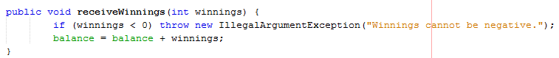

Before Result:-

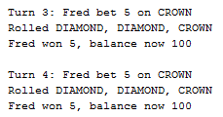

After:

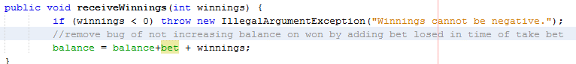

After Result:-

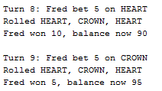

**2. The limit set to 0 but Game end still player have 5 dollars.**

**Before:**

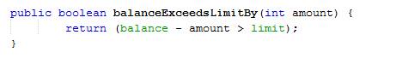

Before result:-

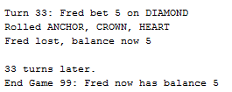

After:

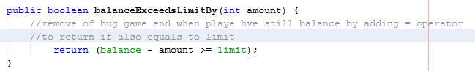

After result:-

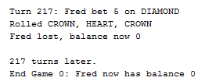

**3. Showing same rolled on all turn and in all games.**

Before:

Position of initialization of dice values before

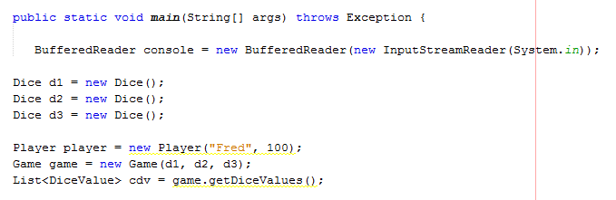

Before Result:-

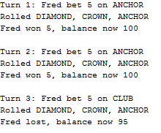

After:-

Position of initialization of dice values After

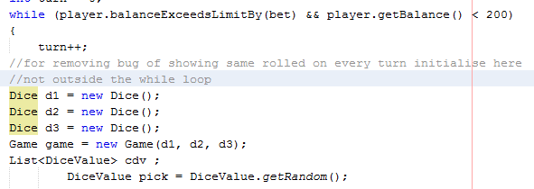

After Result:-

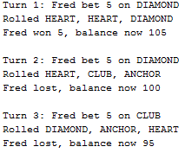

**4. Odds in the game do not appear to be correct.**

Before:

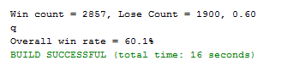

After: After fixing all above bugs rate auto change

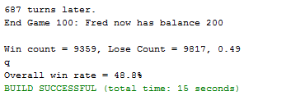

**5. Game start with start Game 0 not from 1.**

Before:



Before Result:-

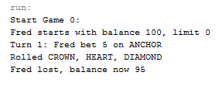

After:

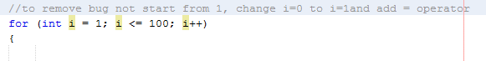

After Result:-

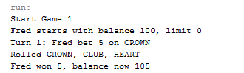

**6. No Message for quit.**

Before:

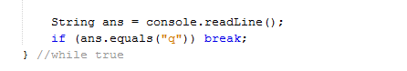

Before Result:-

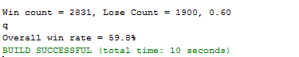

After:

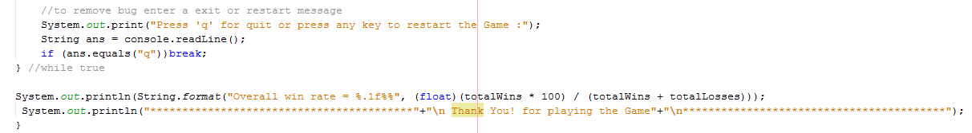

After Result:-

1.

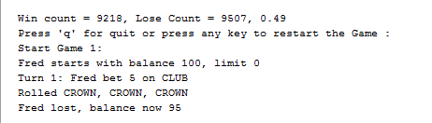

2.

